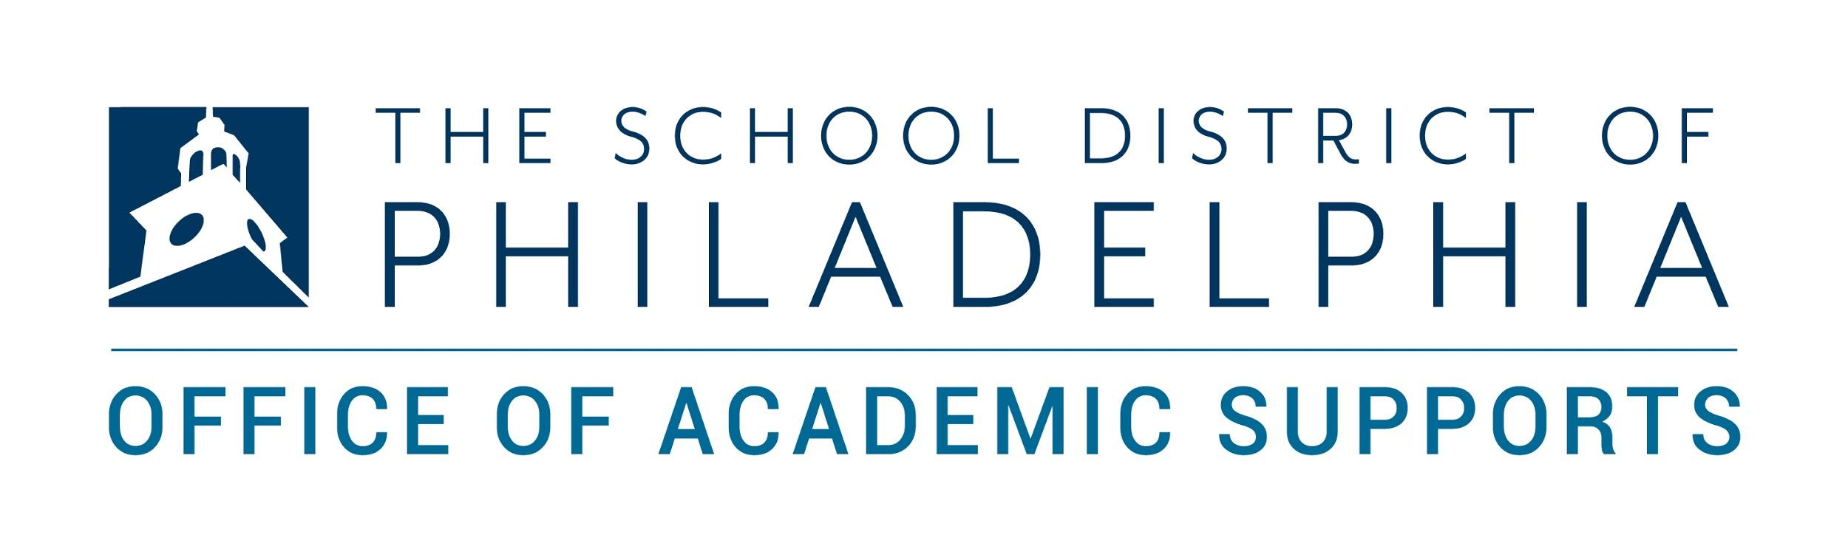

Parents and Families,

We are excited to announce that students are now able to get a snapshot of their performance in school, all on one page! This report is available for students grades 6-12.

**What is the Check and Reflect Report?**

This “snapshot” is called the ***Check and Reflect Report***. It gives students information about their:

* Attendance
* Behavior
* Grades

These are the three main components that predict if a student is on-track to be promoted to the next grade, and ultimately, graduate on time.

**What does it look like?**

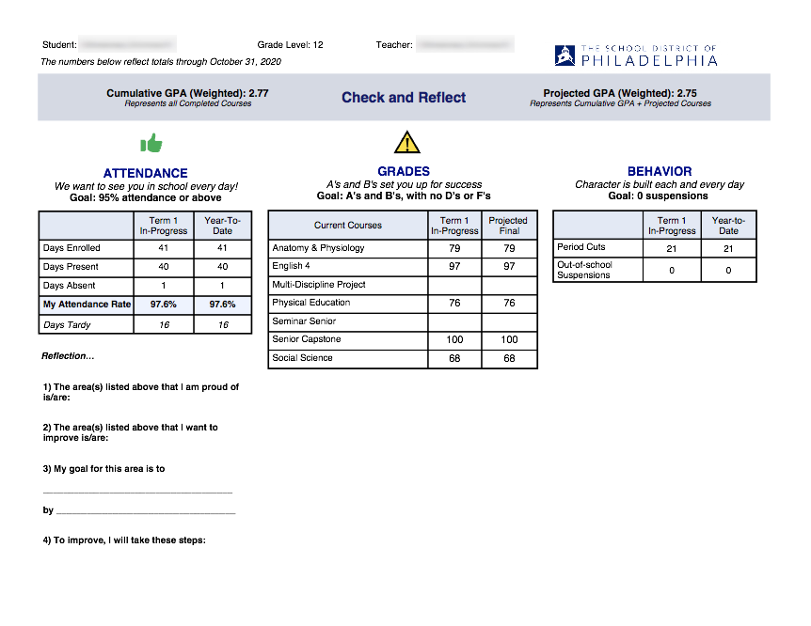

**What should I do with it?**

The *Check and Reflect Report* is a great way to see an overall view of how your student is doing in school. It is also a good resource to use to “check in” with your student and talk about what’s going well and ways to improve. At the bottom of the report, there are 5 prompts:

* These area(s) listed above that I am proud of is/are: __________________________
* The area(s) listed above that I want to improve is/are: ________________________
* My goal for this area is to _____________________________________ by ___________________________________
* To improve, I will take these steps: ________________________________

You could use the above questions to start conversations with your student to celebrate their wins as well as make an action plan to support them in improving grades, attendance, and behavior.

The main purpose of this report is for your student to be aware of where they stand as a student, to celebrate their successes, and to make adjustments as they need to. It is also geared to support families in having conversations about academic progress.

The report updates weekly, with a new one available in the Parent & Family Portal on Monday mornings.

This report does not replace the interim report or the report card. This report shows where a student stands at the point in time that the report is updated.

**How can I find it?**

The *Check and Reflect Report* is available through Campus Parent - the District’s Parent & Family Portalsystem, the same tool where you can see your student’s grades.

If you are signed up for the Parent & Family Portal, you will be able to access it from your devices. Directions to sign up for the Portal are here: <https://www.philasd.org/pfportal>

Once you have created your Parent & Family Portal account, use the stepper linked below to access the Check and Reflect Report.

* [Viewing Check & Reflect in Campus Parent Stepper](https://drive.google.com/file/d/1CQv-3DiXGf7Rj-EIAu9UF4u9ynxQld9r/view?usp=sharing)