To all:
By Tuesday morning all HR teachers will have received a list of their ADV students highlighting those students where we have a discrepancy with their Chromebook Serial Number, SN. We are asking for help to once and for all get these discrepancies under control as it has been a daunting task for everyone concerned.
We are asking that you confirm the SN for the student with the Chrome book they have in possession. SNs can be found on the back of the laptop:
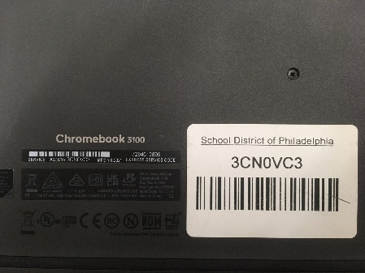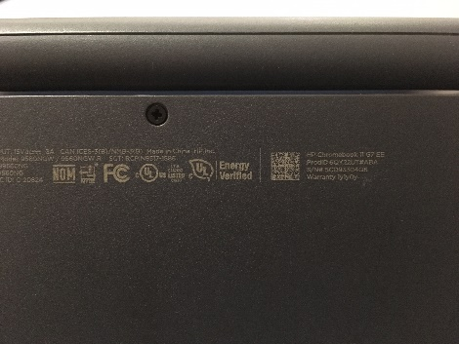
DELL HP
The Dell machines may also have a tag on it which makes the number easy to find. The SN is the same as Service Tag number. For an HP, the number is located towards the upper right-hand corner of the Chromebook. If there is no visible SN to be found, please use this link to learn how to find the SN, (25 sec.).
How to find CB Serial Number
<https://www.youtube.com/watch?v=RIjU8qvqKMA>
All you need to do is this: before you log onto your account, press the keys alt-v and the SN will appear in the top right-hand corner of the screen.
There are mainly 3issues you will encounter:
- The student may have multiple machines, please verify the correct SN and ask the student to return any machine they may still have in their presence.
- A student has no SN with machine.
- A student SN begins with UNV, this is an invalid number.

You may not see these students regularly during your ADV, however, if you see them any of them during the school day, especially if you have them for a class, please try to obtain the SN in question.
I would like to collect the spreadsheets back on Wednesday and/or Thursday if possible and then you can let me know if there are any issues that need to be addressed. If this is not enough time, no problem either but we need to get a handle on this. Once this happens and the district’s supply chain becomes functional again, we may start having a functional replacement process in place beginning with 3rd marking period.
Thank you for your support with task.
Sincerely,
Mr. Brubaker

