This stepper shows students and staff how to launch the Bluebook testing app from School District of Philadelphia issued student Chromebooks. This app will be used to complete the Digital Readiness Check, complete test preview or full-length practice, and for actual testing on test day(s).

NOTE: A College Board account is needed in order to log into the Bluebook app.

Table of Contents
- Launching the Bluebook Testing App
- Accessing the Digital Readiness Check
- Accessing Test Practice Outside of the Digital Readiness Check
- Accessing the Test on Test Day

Launching the Bluebook Testing App
- Turn on the Chrombook but DO NOT login.
- Click “Apps” on the bottom left corner of the screen to view available apps.
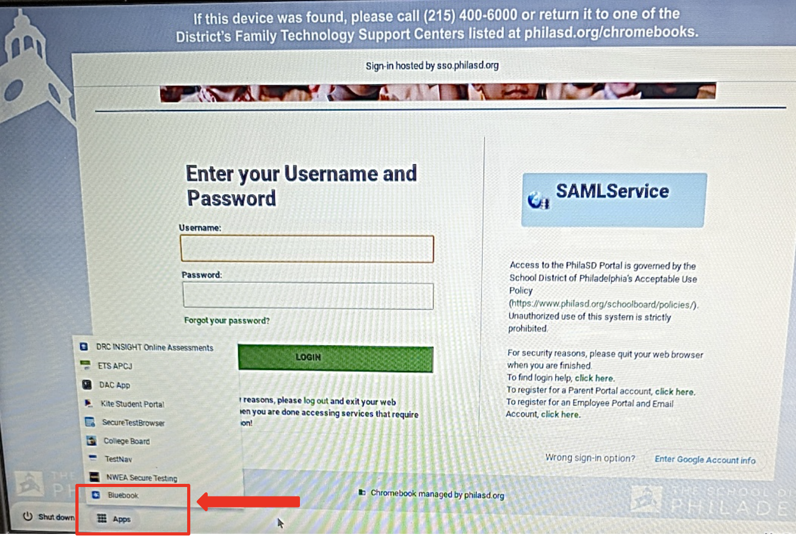
- Click “Bluebook”

Accessing the Digital Readiness Check
- After opening the Bluebook app, click “Use a sign-in ticket from your school”.
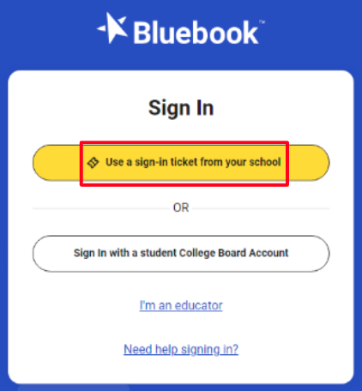
- Enter the login credentials as shown on your sign-in ticket and follow the directions on screen to complete the Digital Readiness Check.
  - You will need a sign-in ticket from a teacher or other school staff in order to complete the Digital Readiness Check.

Accessing Test Practice Outside of the Digital Readiness Check
- Open Bluebook and click “Sign in with a student College Board Account”.
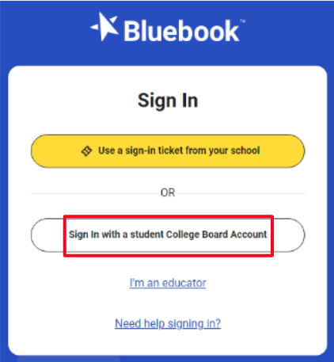
- Sign in using your College Board login credentials.
  - If you do not yet have a College Board account, create one by visiting the College Board website.
- Agree to the privacy policy and click “Next”.
- Read the information on the next screen and click “Next” again.
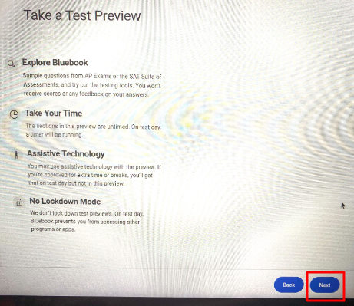
- You will be given the option to select “Test Preview” or “Full-Length Practice” on the next screen.
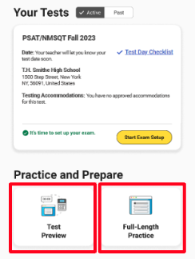
- Selecting “Test Preview” will allow you to test out the tools, navigation, and preview the layout of testing within Bluebook.
  - Choose a preview by selecting “SAT Suite of Assessments” from the drop down menu. Then, click “Next”.
  - Then, begin your test preview.
- Selecting “Full-Length Practice” will allow you to complete a full-length practice test for the SAT, PSAT 8/9, or PSAT NMSQT.
  - Select either “PSAT-Related Assessments” or “SAT” from the dropdown menu based on the test you want to practice. Then, click “Next”.
  - If you select “PSAT-Related Assessments”, you will need to select which test you want on the next screen.
  - If you will be testing with accommodations on test day, select the slider next to “I will be testing with accommodations”. Then, click “Next”.
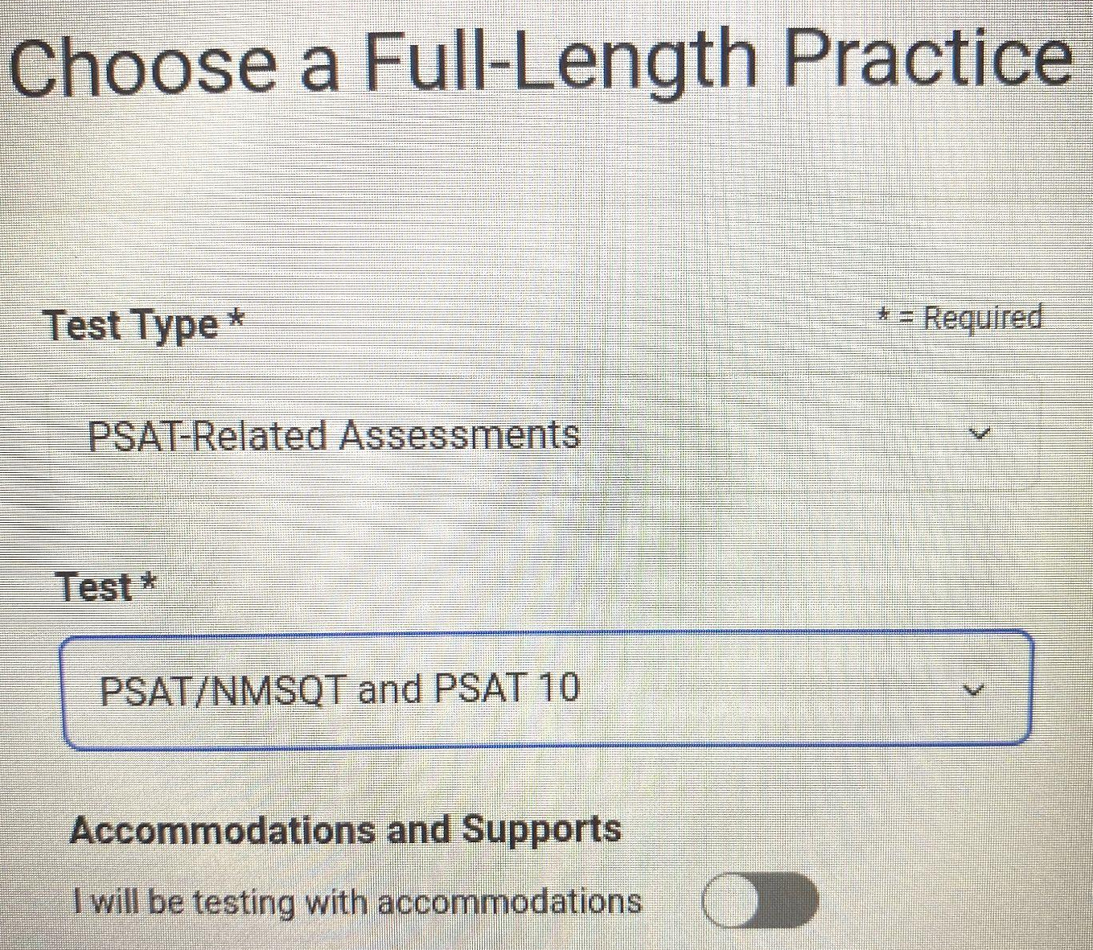
  - If you will not be testing with accommodations, click “Next”.
- Your full-length practice screen will look similar to the screen shown below and will include a countdown timer at the top.
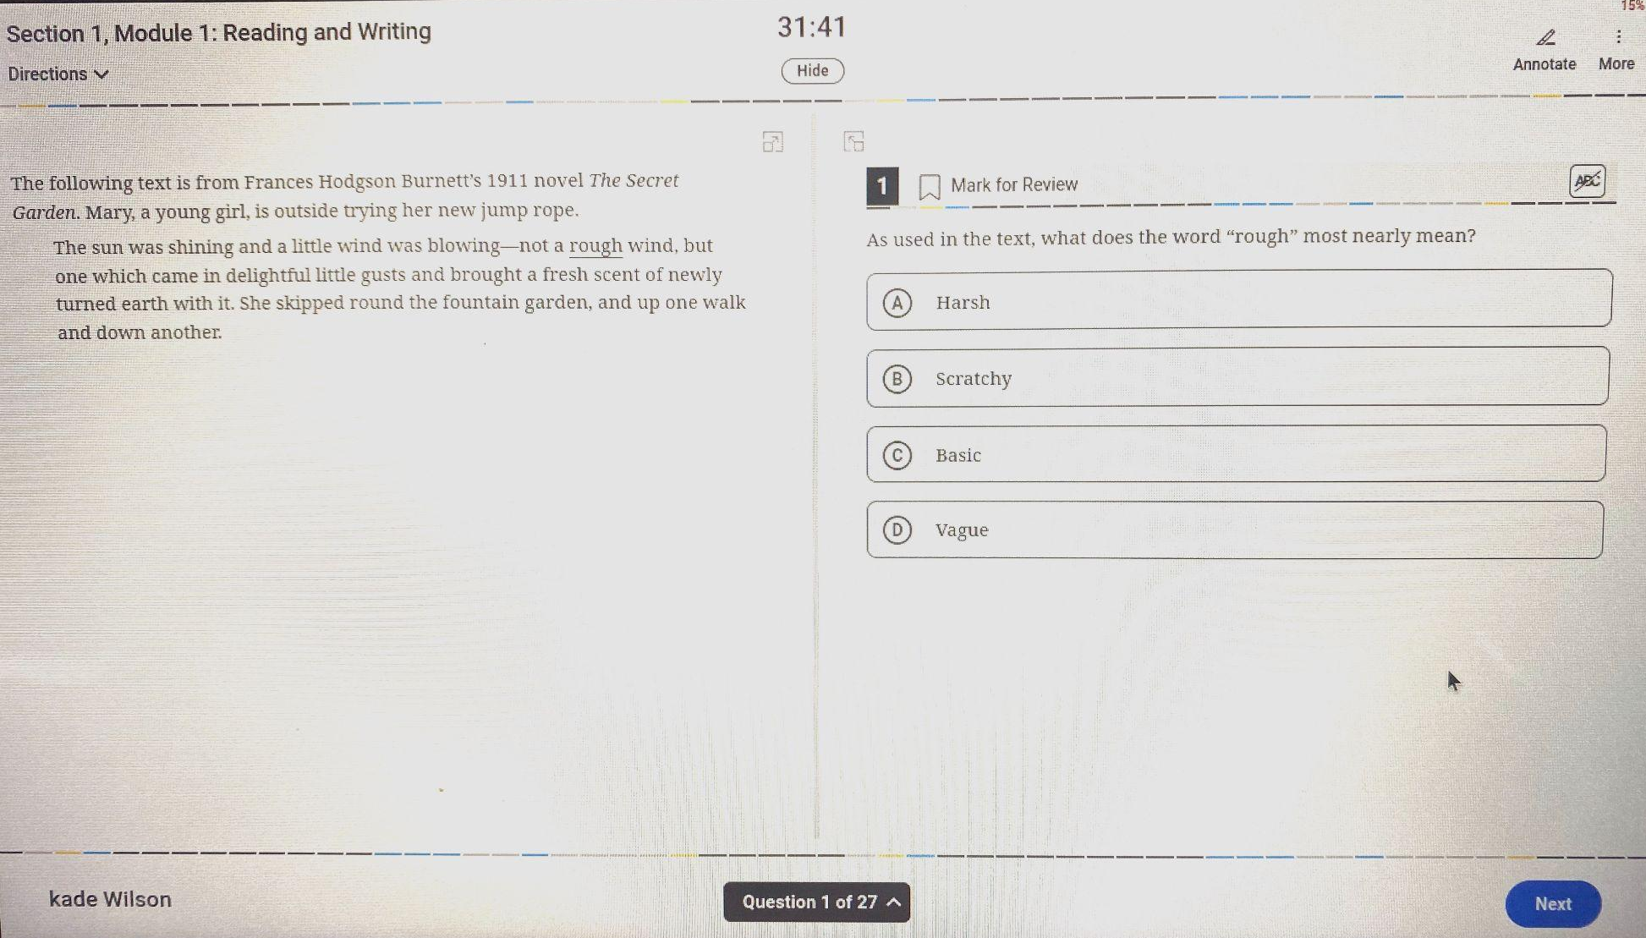
- Additional full-length practice test information:
  - If you take a full-length practice test, your scores will be available on My SAT.
  - If you take a practice test more than once, you’ll see one listing for it on the “Past” tab under “Practice and Prepare”. When you go to My SAT, each completed test will be listed.

Accessing the Test on Test Day
- After opening the Bluebook app, click “Use a sign-in ticket from your school”.
- You will need a sign-in ticket from a teacher or other school staff in order to sign into Bluebook for testing. Enter the login credentials as shown on your sign-in ticket.
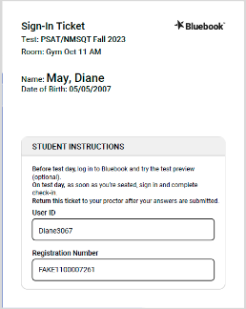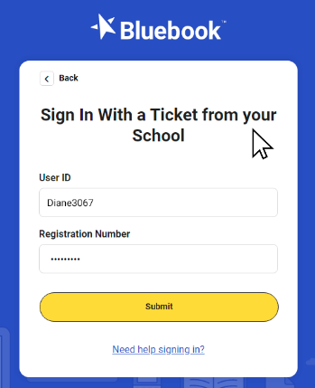
- Read and agree to the privacy policy if you haven’t already done so during the Digital Readiness Check.

- If you are registered for a test you should see it in the “Your Tests” section of the next screen.
- You should see a “Start Exam Setup” button as shown below. Click that button to begin.
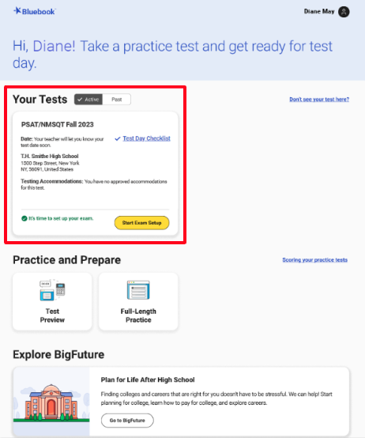
  - Confirm your name and any approved accommodations on the next screen.
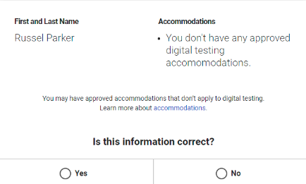
  - Read and agree to the Digital PSAT 8/9 or NMSQT Testing Rules on the next page.
  - If you’d like to access BigFuture School to view your scores and get customized career information, enter your information on the next screen.
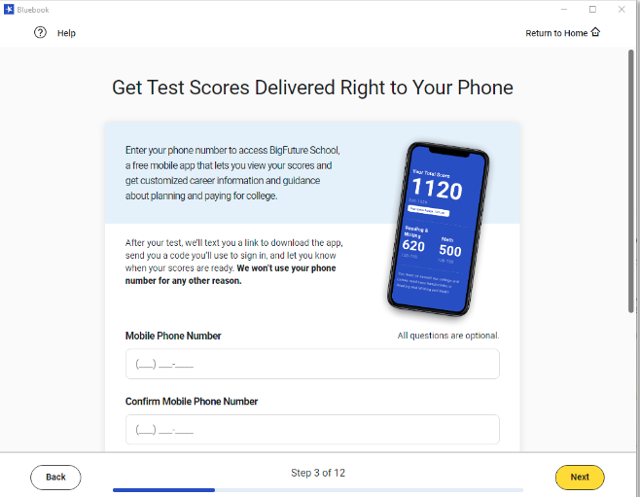
  - Students taking the PSAT NMSQT will see an additional privacy notice including optional questions on the next screen.
  - Students taking the PSAT NMSQT will be given the opportunity to opt-in to Connections (free program that lets you hear from Colleges and Scholarship programs looking for students like you) on the next screen.
  - Review the Test Day Checklist on the next screen.
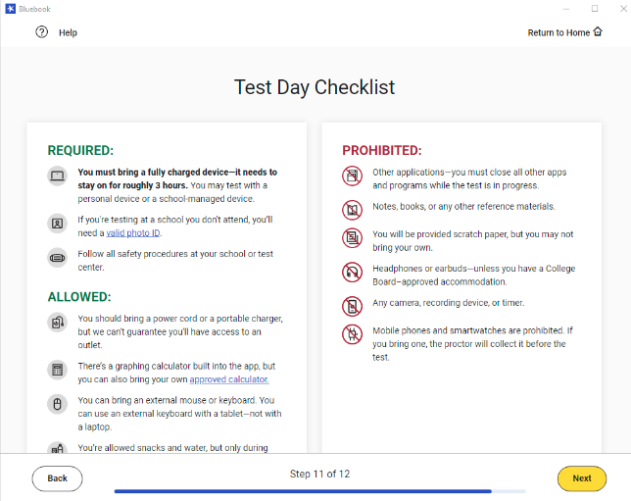
  - Exam setup is now complete. Click “Return to Home”.
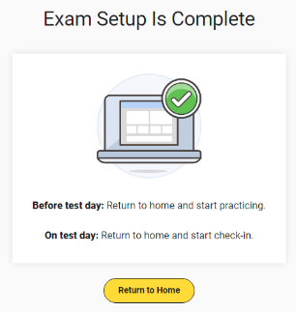
- Click “Check In Now”.
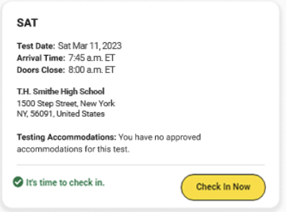
- Once you have completed check in, wait for instructions from your Test Administrator.
- Enter the Room Code provided to you by your Test Administrator.
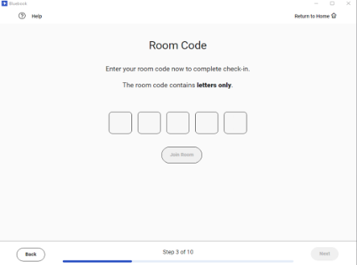
- Next, your exam will be downloaded onto your Chromebook. Once that is complete, follow the prompts on the next few screens to complete the following:
  - Test Security Pledge
  - Get your desk ready
  - Short, silent testing tools video
  - Read the test overview and directions
  - Computer lockdown mode information
- You will receive a test Start Code from your Test Administrator and click “Start Test”.
