Kooth: A Quick Reference Guide

Registration Link QR Code

The Kooth platform is available 24/7, with highly qualified, licensed counselors available for chat sessions between 6-10pm, seven days per week. All content is reviewed before being posted and may take up to 24 hours to appear once you’ve entered it.

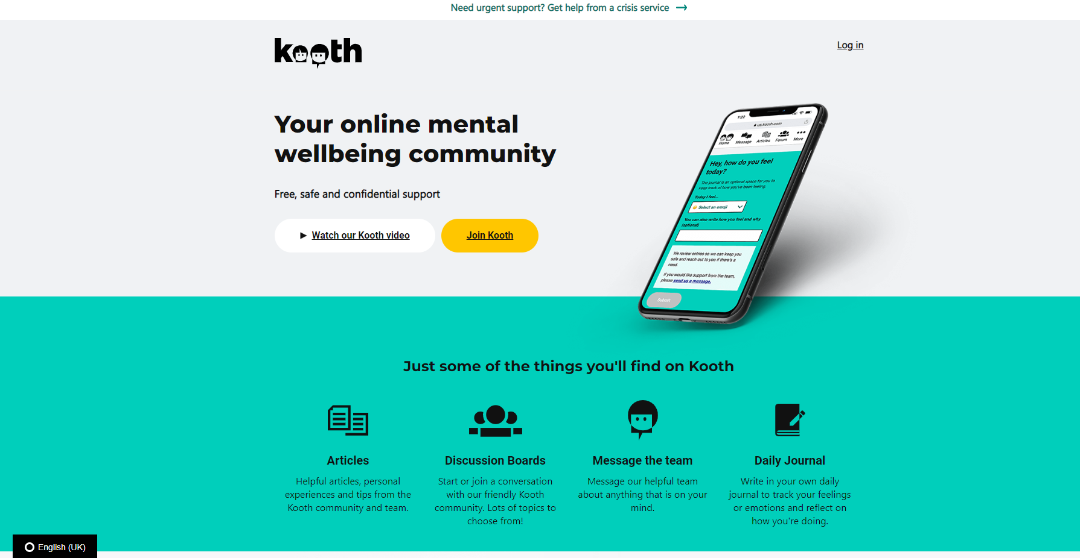
Exploring the site

Registration
Creating your Kooth account is quick and easy. Scan the QR code at the top of this page or navigate to us.kooth.com
on your browser and select Join Kooth. Complete the registration steps, make a note of your username and password, and you’re all set! Going forward, you’ll select Log in to sign into your account.

Homepage
When you log-in you’ll be taken to your Homepage. From here you can enter a journal entry at the top of the page, see updates on posts or discussion boards, navigate to other parts of the platform, and send feedback to Kooth.

Navigating Kooth
Kooth’s online mental wellbeing community is designed so you can choose how YOU would like to use it. Let’s explore the different options!

The icons at the top of the page can be used for easy navigation or you can scroll down to see suggested resources. Clicking the Kooth icon on the left will always bring you back to the Homepage.

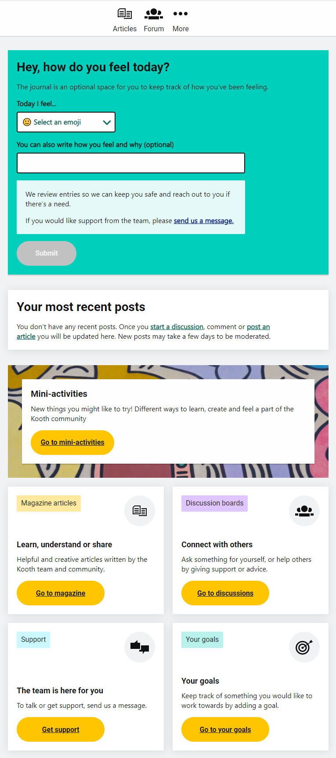
(1) Journal - Take a moment to check-in on how you’re feeling and write down your thoughts.

(2) Mini Activities - Quick activities or suggestions to try on your own that are designed to boost your mental health and wellbeing. Try the Dance like nobody's watching or Be part of the Kooth community activities to get started!

1

(3) Articles - A great place to find articles from mental health professionals and also from your peers. Like video games? Check out the Staying switched on: gaming and well-being article. You can help others by Contributing your own writing! See something you’re interested in? Add to favorites and come back to it later.

2
(4) Forum - Kooth Forums are discussion boards available as a constant source of support. See how your peers are feeling and the experiences they’re going through. Start a discussion of your own or offer your words of advice and encouragement on an existing thread.

(5) Chat - The items above are self-guided and/or are focused on interactions with your peer community. Click the Chat icon if you’d like to talk 1:1 to a Kooth Professional.

4

3

(6) Goals - Set a goal for yourself and track your progress towards achieving it. Goals are tracked on a scale from 1-10 and once you reach 10 you can mark it as complete!

5

6

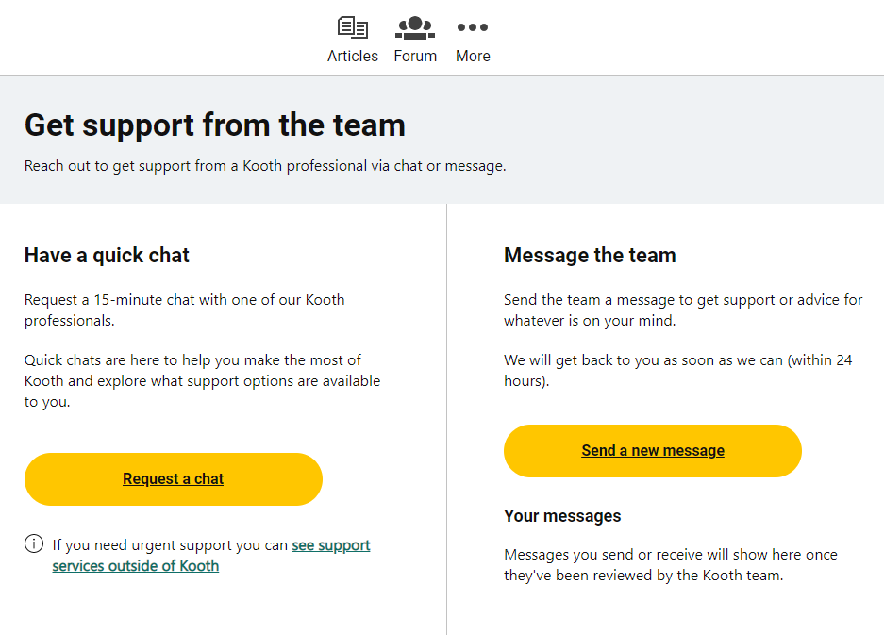
Chat with a Kooth Profesional

1

5

6

2

4

3

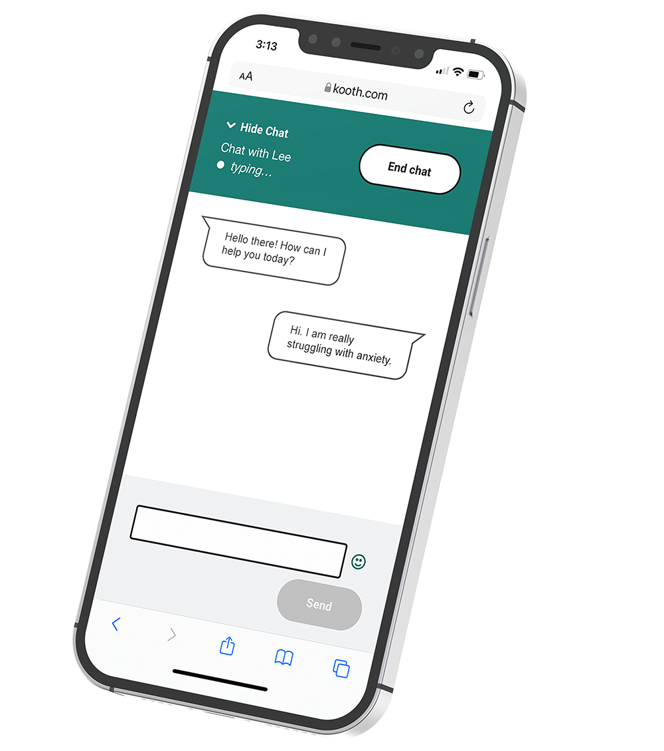
(1) Access the Support Page by either clicking Chat from the top navigation bar or clicking Get support from the Homepage.
(2) Click Request a chat to schedule a chat with a Counselor.
(3) When a Counselor is ready, the Chat Bubble appears at the bottom of the screen.
(4) The Request a chat button will be updated to Open my chat. Click it to launch the chat dialog with the Counselor. The Kooth Counselor will get to know you and understand the type of coaching support you'd like to receive.
(5) Kooth will match you with a Counselor and get you connected. Alternatively, you can click More > Meet the Team and learn a little bit about the team of counselors and decide if there’s someone in particular you’d like to chat with.
(6) Select Send a new message if you’d prefer to send a message to the Kooth team. This is a great option when you just want some advice or tips for something you’re experiencing. Keep your eye on your message inbox - a member of the Kooth team will respond back to you within 24 hours!

