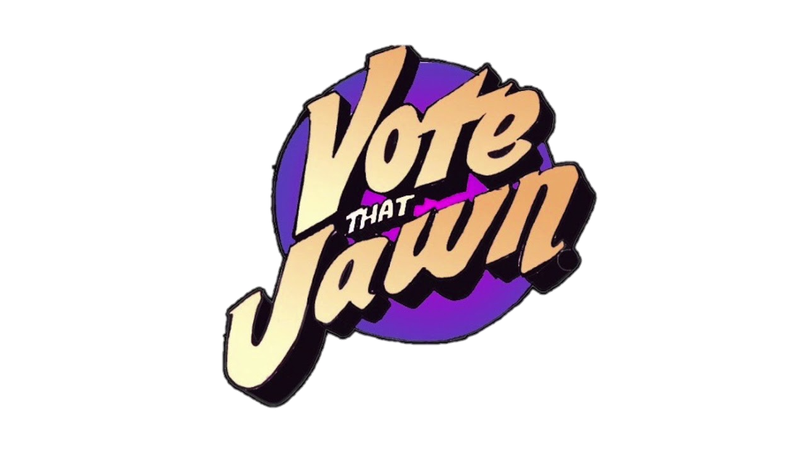

**Summer Jawn 2025**

**Summer Intern Job Description**

**Application Deadline: Friday, May 9, 2025**

**Position:** Summer Intern

**Stats**: June 23, 2025-August 1, 2025 (6 weeks)

20 hours per week

Hybrid with 1-2 weekly in-person sessions required in Center City, Philadelphia

**Stipend**: $1,800

**About** [**#VoteThatJawn**](https://www.votethatjawn.com/) **(#VTJ)** **and Summer Jaw 2025**

#VTJ adds value to youth voter engagement initiatives (its own and partner programs) by

coordinating and facilitating creative content--long- and short-form writing, social media visual

and video content--that is created by high school and college youth to amplify their voices.

Through a six-week hybrid program in the Summer of 2025, #VoteThatJawn will engage a dozen paid high school and college students, (20 hours per week), to create written, spoken, videoed, and other creative works with spoken word poetry as anchor.

Spoken word taps into Philadelphia’s vibrant spoken-word scene, and its feisty recent history of national excellence. In addition, we will encourage plenty of blog writing and other creative forms about subjects that matter deeply to our youth: education funding, from K-12 to higher ed loans, justice, climate, gun control, gender parity, LGBTIAQ rights, and abortion access. Vote That Jawn and its content is non-partisan, focusing not on party, but on issues affected by voting, emphasizing local and organic, as we near the November 2025 elections. This summer, use your creative talent and energy to promote voting, democracy, and the issues that matter most to young people with Vote That Jawn!

**About you:**

You’re a creative, open-minded high school or college student (recent grads count!) who is excited about using their voice to get out the youth vote and amplify the issues that matter most to young people.

Maybe you have a specific passion for graphic design, writing, creating videos, or doing spoken-word poetry-- all the better! New to all of this? We welcome your application. Summer Jawn is a place to learn new skills and grow your existing ones. Enthusiasm and a willingness to learn are the most important aspects of being a Summer Jawn intern. We are especially looking for candidates who are excited to share their creativity with others.

**About the internship**

As a Summer Jawn intern, you are expected to work 20 hours a week. While the majority of this work will be remote, interns will meet in person once a week in central Philadelphia for workshops, one-on-one meetings with their supervisors, and occasional guest speaker events. Interns will be paid via check on a biweekly basis.

Responsibilities and requirements for this role include

* Weekly meetings with your assigned youth leader and/or a VJT co-director
* Attending all in-person events
* Creating regular content in one or more of the following areas: audio/visual projects, writing blog posts, spoken word poetry, or graphic design.
* Collaborating with other Summer Jawn interns on content development and creation

Successful applicants will demonstrate enthusiasm, a willingness to learn, and creativity!

**The Position**: Apply [here](https://forms.gle/7cawWhgeHqaphcw78)!